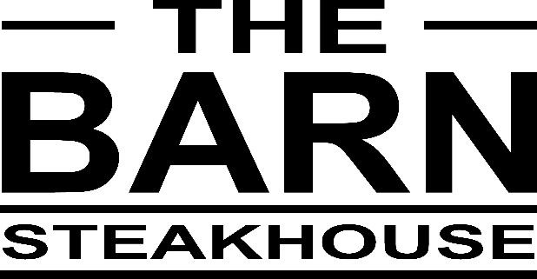

Clydesdale Motel & Steakhouse Covid 19 rules – 11th of October 2021

As per the NSW Government Health orders you must be fully Vaccinated to dine in at the Steakhouse.

Bookings are a MUST and will only be taken over the phone where your name and phone number will be recorded. If you are feeling UNWELL please stay at home.

All persons will be required to REGISTER by the QR code process upon arrival and show proof of double dosed vaccination as per the NSW Government Health orders (either paper copy or electronic)

Masks MUST BE WORN on arrival and leaving the Steakhouse and can be taken off once your seated at your table. You MUST wear a mask when you come to the bar or go to the toilet please.

A maximum of 40 people ONLY may dine inside the Steakhouse and a maximum of 20 people ONLY in the verandah area at anyone time with the 1 per person per 4m2 rule applied. If you dining outside on the Front Lawn you may stand whilst drinking but must be seated whilst eating.
Customers dining inside the Steakhouse MUST remain seated at their table except when using the facilities or getting drinks from the bar where you need to line up with the floor markings and adhere to the 1.5m social distancing rule.

Individuals group bookings dining within the Steakhouse cannot move from one group or table to another, you MUST stay with your booking group/table and remained seated.

Your meal order and payment (cards preferred) will be taken at your table.
Table settings will ensure there is 1.5 metres between different groups of customers.
Readily available sanitisation units are available for all for guests throughout the Steakhouse and social distancing and hygiene signage and visual cues will be around the venue to remind you.
Regimented strict cleaning and sanitisation procedures are carried out in the Steakhouse daily.

We are committed to ensuring that your safety is out highest priority. We ask that you assist us by following these NSW Government Health orders and we thankyou for your patience and understanding in these unprecedented times and please note and we look forward to seeing you back at The Steakhouse soon.

Cheers Stu & Marg

