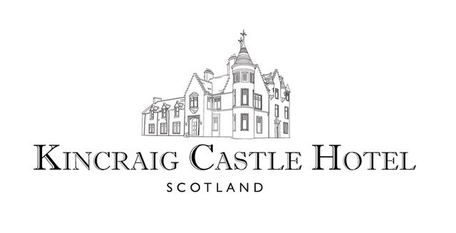

To Start

Our Snacks £5.50

Our Bread | Marinated Olives | Cheese Straws

Smoked Chicken Salad £7.50

Crispy Skin | Sultana | Wild Rice | Coronation Dressing

Isle of Lewis Mussels £6.50/14.00

Caledonian Best Beer | Double Cream | Chives

Risotto Primavera £7.50/14.00

Peas | Samphire | Spinach | Crème Fraiche

Roast Asparagus £7.50

Hollandaise Sauce | Poached Egg | Truffle Dressing

Cullen Skink £7.00

Smoked Haddock | Leek | Potato

Seafood Platter (For Two) £20.00

Crab Salad | Prawn Cocktail | Smoked Salmon | Mackerel Pate

Mussels | Brown Bread | Lemon

Eggs Benedict £7.50

Toasted Muffin | Poached Egg | Hollandaise Sauce | Ham

Soup of the Day V £5.50

Changes daily





To Follow

Fish & Chips£14.50

Beer Batter Haddock | Peas | Chunky Chips | Tartare Sauce

Steak Burger £14.50

Brioche Bun | Dill Pickle | Tomato Relish | Onion Jam | Chunky Chips

10 oz Sirloin Steak £24.50

Tomato & Mushroom | Onion Rings | Chunky Chips | Peppercorn Sauce

Pot Roasted Lamb Rump £18.50

Sweet Potato | Madras Spice | Spinach | Roast Garlic Biriyani

Chicken Kiev £14.50

Garlic & Parsley Butter | Polenta Crumb | Rosemary Carrots

Crab Linguine£14.00

Chilli | Spring Onion | Roast Pepper | Saffron | Tomato

Roast Gammon Steak £14.50

Black Pudding Mash | Fried Egg | Pineapple Chutney | Hp Sauce

Pesto Linguine £13.50

Rocket Pesto| Pine kernels | Ricotta | Basil

Steak & Black Pudding Pie £12.50

Shortcrust Pastry | Buttered Vegetables | New Potatoes

Sticky Toffee Pudding £5.50

Butterscotch sauce & Ice Cream

Dessert Daily Special £6.50

Ice Creams & Sorbet £5.50

Cheese Selection £10.00