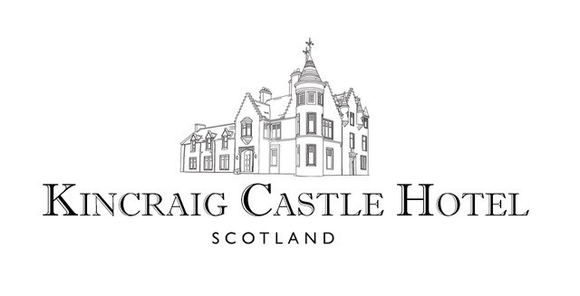

**Light Lunch Menu**

**To Start**

Homemade Soup £5.95

Kincraig Bread & Butter

Roast Porchetta, Onion Jam & Rocket £7.95

Ciabatta Bread | Salad | Coleslaw

Rib-Eye Steak, Cream Mushrooms & Smoked Applewood £9.95

Ciabatta Bread | Salad | Coleslaw

Smoked Salmon & Cream Cheese £8.50

Ciabatta Bread | Salad | Coleslaw

Cheddar, Onion Jam & Creamed Mushroom (V) £7.95

Ciabatta Bread | Salad | Coleslaw

Tempura Battered Sea Bream £12.95

Crushed Potato | Pea Purée | Warm Tartare Sauce

Roast Chicken Caesar Salad £11.00

Croutons | Parmesan | Bacon

(Available as a Vegetarian dish without Chicken & Bacon)

Mussels Marinière £14.50

Toasted Bread | Salsa Verde

Braised Venison & Stornoway Black Pudding Pie £13.95

Onion Mash | Chef’s Gravy





Classic Sandwich Selection £6.25

On Wholemeal or White Bread from the following selection:

* Cheddar Cheese & Chutney
* Smoked Salmon & Herb Cream Cheese
* Honey Roast Ham & Arran Mustard Mayonnaise
* Free Range Egg Mayonnaise & Cress

Homemade Soup & Sandwich Combo £10.00

Any Sandwich from our Classic Sandwich Selection

Side Orders:

* Chips £3.50
* Seasonal Vegetables £3.50
* Onion Rings £3.50
* Side Salad £3.50

**To Finish**

Kincraig Apple & Blackberry Crumble £6.95

Homemade Vanilla Ice Cream

Chocolate & Peanut Fondant £6.95

White Chocolate Sauce | Homemade Dalmore Malt Ice Cream

Drambuie Parfait £7.95

Raspberries | Oat Crumble

Scottish Summer Berry Tart £6.95

Crème Pâtissière | Raspberry Sorbet

Sticky Toffee Pudding £6.95

Butterscotch Sauce | Homemade Vanilla Ice Cream