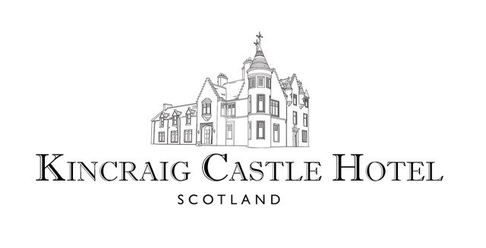

**To Start**

Pigeon & Pancetta Wellington £8.95

Pickled Mushroom | Golden Raisin Purée

Seared Scottish Scallops £9.95

Stornoway Black Pudding | Smoked Apple

Kincraig Crab Bisque £8.00

Poached Seafood | Saffron Potato | Aioli

Duck Liver Parfait £7.95

Cured Egg Yolk | Crispbreads | Homemade Spiced Chutney

Home Smoked Salmon £8.95

Pickled Vegetables | Oatcakes | Herb Salad

Moray Firth Mussels Marinière £7.95

Toasted Bloomer | Salsa Verde

Homemade Soup £5.95

Kincraig Bread & Butter

Caramelised Goats Cheese & Poached Pear (V) £6.95

Onion Jam | Brown Bread Cracker

Caesar Salad (V) £5.95

Croutons | Parmesan

(Also available as a Main Course with or without Chicken)

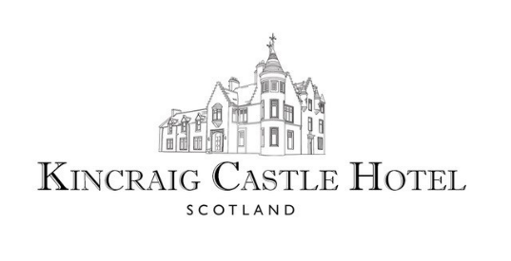

**To Follow**

Trio of Pork £17.95

Apple & Vanilla Purée | Savoy Cabbage | Grain Mustard Sauce

Crispy Skinned Duck Breast £19.50

Duck Leg Stovies | Choucroute | Poached Quince | Anise Jus

Rib-Eye Steak (10 oz.) £26.95

Wild Mushroom Gratin | Onion Rings | Skinny Fries | Peppercorn

Amy’s Singapore Chicken £13.95

Coconut Rice | Pak Choi | Cucumber & Pineapple Salsa

Tempura Battered Sea Bream £14.95

Herb Crushed Potatoes | Pea Purée | Warm Tartar Sauce



Charred Fillet Salmon £15.95

Salt Baked Beetroot | Scallions | Mussels Chowder

Whole Baked Lemon Sole £16.95

Saffron Potatoes | Seasonal Vegetables | Rosemary Butter Sauce

Crowdie Cheese & Polenta Beignet (V) £13.95

Foraged Mushrooms | Spinach | Confit Tomato Fricassé

Risotto Primavera (V) £13.95

Asparagus | Peas | Samphire

Chips, New Potatoes, Seasonal Vegetables or Salad £3.50

 

**To Finish**

Kincraig Apple & Blackberry Crumble £6.95

Homemade Vanilla Ice Cream

Chocolate & Peanut Fondant £6.95

White Chocolate Sauce | Homemade Dalmore Malt Ice Cream

Drambuie Parfait £7.95

Raspberries | Oat Crumble

Scottish Summer Berry Tart £6.95

Crème Pâtissière | Raspberry Sorbet

Sticky Toffee Pudding £6.95

Butterscotch Sauce | Homemade Vanilla Ice Cream

Trio of Kincraig Desserts £9.50

Kincraig Apple & Blackberry Crumble | Drambuie Parfait |

Scottish Summer Berry Tart

Kincraig Ice Creams & Sorbets £5.95

Selection of Homemade Ice Creams & Sorbets

 

**Scottish Artisan Cheese Selection**

Morangie Brie

A smooth, sweet, creamy cheese made from pasteurized cow's milk, produced nearby by the Stones family of Highland Fine Cheeses at Blarliath Farm near Tain

Strathdon Blue

A rich, creamy blue cheese made from pasteurized cow's milk produced by the Stones family of Highland Fine Cheeses at Blarliath Farm near Tain

Smoked Dunlop

A delicious Scottish cheddar cheese, traditionally smoked using oak whisky barrel shavings produced by the Connage Highland Dairy near Ardersier

Orkney Cheddar

A multi-award winning mellow, creamy cheddar cheese with slightly sharp, savoury & nutty notes produced by the Orkney Creamery

Served with Grapes | Chutney | Scottish Oat Biscuits & Crackers

£10.00

