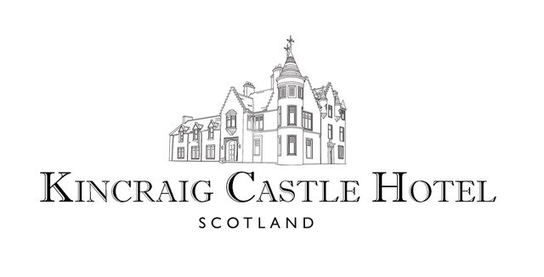

**Taste of Scotland**

Chef’s Amuse-Bouche

🙢🙠

Cockburn’s Haggis, Neeps & Tatties

Scotland’s Champion Haggis from George Cockburn & Son, Dingwall

🙢🙠

Locally Caught Crab & Seared Scallop

Avocado | Quail Egg | Salt & Pepper Biscuit

🙢🙠

Borders Lamb

Potato Terrine | Cep Purée | Gremolata

🙢🙠

Kincraig Cranachan

Drambuie Parfait | Honeycomb | Raspberries | Oat Crumble

🙢🙠

Brodie’s Coffee

Whisky Fudge

£55

 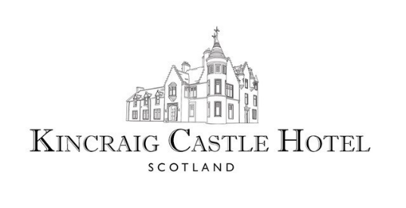

**Artisan Cheese Selection**

Morangie Brie

A smooth, sweet, creamy cheese made from pasteurized cow's milk, produced nearby by the Stones family of Highland Fine Cheeses at Blarliath Farm near Tain

🙢🙠

Strathdon Blue

A rich, creamy blue cheese made from pasteurized cow's milk produced by the Stones family of Highland Fine Cheeses at Blarliath Farm near Tain

🙢🙠

Smoked Dunlop

A delicious Scottish cheddar cheese, traditionally smoked using oak whisky barrel shavings produced by the Connage Highland Dairy near Ardersier

🙢🙠

Orkney Cheddar

A multi-award winning mellow, creamy cheddar cheese with slightly sharp, savoury & nutty notes produced by the Orkney Creamery

🙢🙠

Served with Grapes | Chutney | Scottish Oat Biscuits & Crackers

£10 Supplement