BURGERS
Fat Fox Classic Burger- Cheddar & Bacon £12
Hot Fox Burger- Jalapenos, Crème Fraiche & Mexican Cheddar £10
Foxy Bleu Burger- Stilton, Red Onions & Mushrooms £10
Foxy Chicken Burger- Chicken Fillet, Bacon, BBQ Sauce & Cheddar £10

ALL BURGERS SERVED ON A BRIOCHE BUN, BABY GEM LETTUCE, PLUM TOMATO + FRIES

PUB CLASSICS
Brakspear Beer Battered Fish + Chips- Mushy Peas & Tartare Sauce £13.50
Gammon Steak- Free Range Egg, & Chips £12
Foxy’s Pie of The Day – Seasonal Veg, Mashed Potato & Gravy £12

Ice Cream Yarde Farm Mini Tubs (Various Flavours) £2.25
BEER
Estrella ½- £2.45
Estrella PINT- £4.90
San Miguel (Bottle)- £3.80
Heineken O (Bottle)- £2.90

SPIRITS- Spirit(25ml) + Mixer £4.75
Jack Daniels/Vodka/Bacardi
Double Up £1.50 Extra per 25ml

GIN- Gin(25ml) + Mixer £5.50
House Gin/Pink Gin
Double Up £1.50 Extra per 25ml

WINE- 125ml- £3.45 175ml- £4.90 250ml- £6.90
Sauvignon Blanc/Merlot/Pinot Rose

COCKTAILS - £8 Each
Fox on the beach, Foxy mojito, Foxy colada, Foxy martini, Flying fox- £8 Each

SOFT DRINKS
Coke, Diet Coke, Lemonade (330ml Bottle) - £2.60
Fever Tree- £2
Water (Still/Sparkling 330ml Bottle)- £3
J2O- £2.40
Juice (Apple or Orange) - £2.50

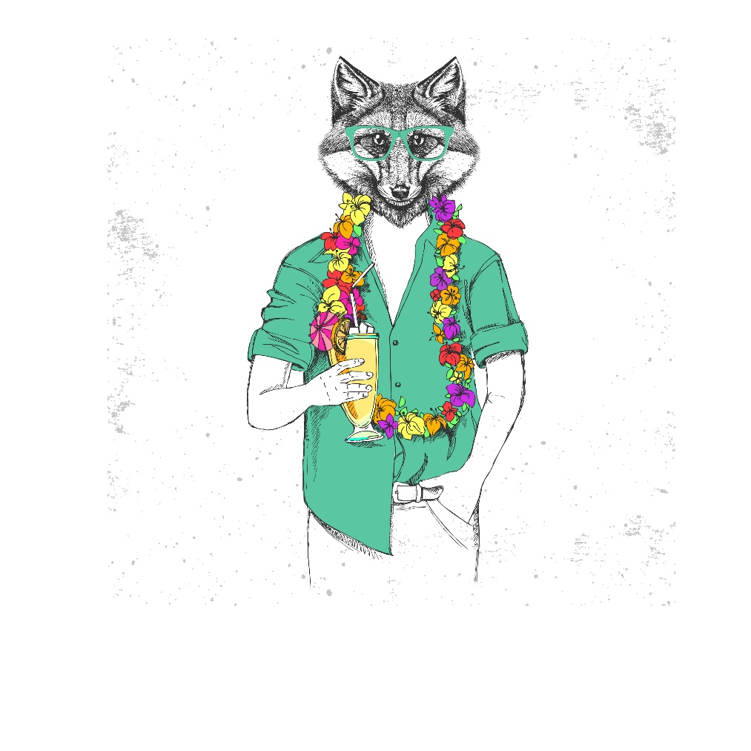

MENU

